General-

If Existing functionality throws error then check it in Android to Confirm if its API issue

Use Windows key and + to start Magnifier and Windows key and Esc to Close it

Use F4 to mute when using Magnifier

Always scroll to Last Read Header in Chats

Day Light Saving starts in March and ends in November

If on Leave, Check Leave days previous days mails from when logged off

Use Copy link option to add Bug details in Chats

To find anyone’s Infomerica Email ID type name name in Search field

When sending Multiple chats always use Word document

In Mobiles Scrollbar is never displayed we need to scroll explicitly

Space between Gear button and Lock button is middle of screen

In Teams use below button to Create Group Chat

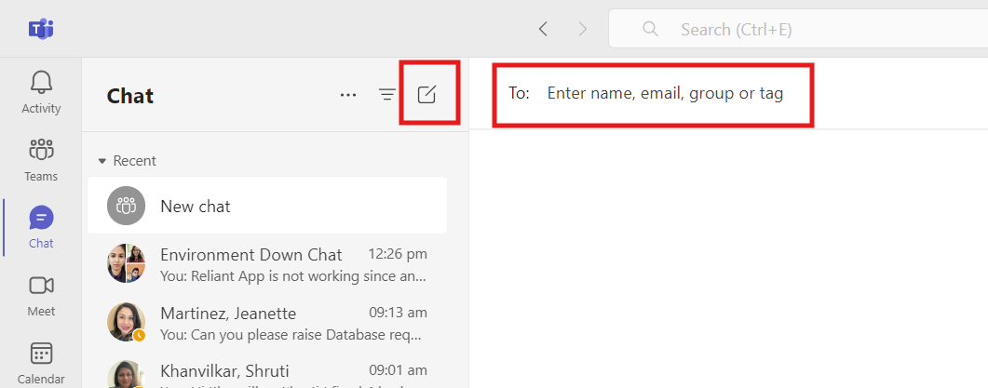

Perfecto-

If below Error appears check if Wifi is turned off

Reports are generated only after Device is released in Manual Testing and Automation

Test Execution sometimes doesn’t display Active sessions hence refer Manual Testing section

Disconnect VPN when installing new Build

To Close Recently Opened App in iOS, use Stop button

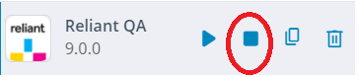

Perfecto Chrome App enlarges App only if moved to Left half of screen

After Opening Device

1)Clear Cache

2)Instead of opening App from Home screen Use

3)Check if Login screen appears in Dark mode

Restart Device

While taking screenshots take with Figma and Perfecto side by side. While taking Screenshot in Perfecto use Snipping tool only so as to capture device name

Screenshots captured manually are saved in Test Report even if Session Expires

Before clicking End and Release Device make sure to select Pass/Fail if Recording is done

If Device doesn’t open then Sign out and Sign in

For Manual testing always used Rarely used iPhones like iPhone 12 Pro Max**(Dark Mode)** as Mode will be changed to Light mode by Others and iPhone 13(15.4) for Automation testing

If iPhone 12 Pro Max is in use, Use iPhone XR**(Dark Mode)** for Manual testing

If Ctrl-C is used to Stop script execution then device can be released as follows

Assets and Setup Sorting

When using iPhone used for Automation replace Automation build by New one

To add Settings etc to Home screen Scroll to Right screen, Press and release the icon, which then becomes large then Drag it out

ADO-

While Creating Bug

1)Title should start with iOS/Android

2)Recheck if Platform used and all other details are correct

Before Save and Close

1)Screenshot and Videos are attached

2)Change Status to Done(Change Status to New if bug is not fixed)

3)Assign To are Changed if bug is not fixed

Before Marking Done Check if

1)Multiple accounts are tested

2)Screenshots/Video are attached

To Create a copy of Testcase select “Copy Testcase(s)” and add below data

For PBIs after Clicking Save and Close

1)Move to RTA

2)Assign to Gary

For adding multiple screenhots use Photos App-Downloads-Gallery Types and Sizes-River and Large

To copy Screenshots from Word to ADO, first copy to Paint and then copy to ADO

To add Link to another PBI or bug use # which populates Auto-suggestions

If a bug has 2 facts in it then use “iOS-a)” in Title

If a Comment is deleted in ADO mails doesn’t get sent

Automation-

Use cls for prev run reslts removal

For TextField always use last 2 nodes of xpath

Never add elements that open after clicking a link in .push in Array creation

To navigate to Beginning and End of spec file for New scripts use Ctrl+Home and Ctrl-End of Numeric Keyboard

Always copy Locator from Perfecto to Notepad, paste Type and then to VS Code

For Locator copy use “Copy Smart Locator” button, then copy to Notepad and Replace * by Type

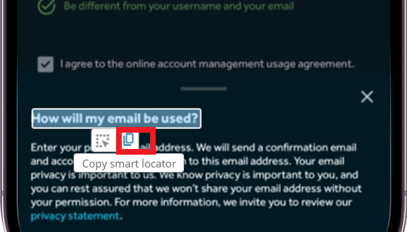

null display happens after each successful command execution

Always use Video View when checking Reports as Step by Step screenshots are displayed

Screenshots are taken before clicking Tiles to get to know what position is the screen before tile clicking

Missing await before Screename.function() will cause Webdriverio to behave Weird

Use Downloaded Perfecto Report Library Report instead of Terminal so that Search functionality will be available

Perfecto Report is generated only after Device is Released

If any changes are done by mistake pull your Branch using Github Desktop

Use Step Over shown in UI

As Tests are terminated with Ctrl-C many times allure-reports folder doesn’t get generated hence check name after deleting 1st folder

To see Console Output Hover over the Time displayed in Report and select Console Output

Full log is to be clicked in Console Output for all Steps display

Use directNavigation() always for new scripts

For Strings comparison use Triple Equals(===)

Shift+C clears Terminal

When execution passes copy HTML Report of Terminal to Testing Videos

To Save Terminal Output to a File Shift+Right Click-Select All

While pasting HTML output to Word select “Keep Source Formatting” while pasting by using Right click

To find a Method in all existing files use Edit-Find in Files

Webdriverio Version check-npx wdio --version

To View all Automation Testcases under iOS PBI Click Links section

Github and Figma-

Before Committing in github Uncomment Existing Testcases in **Spec files(Not Screen folder files)** Commented for New features testing and Comment New Testcases

When Committing in Git Desktop if Authorization error appears select 2nd Button in Popup, signout of github.com and then enter Credentials from ADO Automation Repo

In Github website Backup Drag the folder of local as Folders cannot be created in Github Web

In Figma Hide UI by using Ctrl+\ and press H for Hand tool

Figma link in PBI opens in App only when App is already open

App-

hary is preferred account for testing as it has my nrg email

Staging has Limitations like Bills are not displayed, Ratings cannot be given

Disable Keychain checkbox in Passwords if Save Passwords Popup appears

New Account addition is possible only after deleting Payment Tokens

If an Error like Technical issue/Something is wrong occurs then try signing out and sign-in

When issues are found check for another account before sending to Gary

When copying data to Notes in iOS Ctrl+V will not work Right Click-Paste only will work

Postpaid Prepaid

View Bill Details View Balance Details

Nextbee manages Reliant Rewards

22222 is a Valid Zip Code

After moving tiles Save should be clicked